Chap 1.0: HTML
- Basic HTML
- HTML Heading, Line & Comment
  - Heading
- Help to show the document structure
- Syntax: <h1>…</h1> to <h6>…</h6>
- <h1> is the largest, <h6> is the smallest
<h1>This is a Heading 1</h1>  <h2>This is a Heading 2</h2>  <h3>This is a Heading 3</h3>  <h4>This is a Heading 4</h4>  <h5>This is a Heading 5</h5>  <h6>This is a Heading 6</h6> | 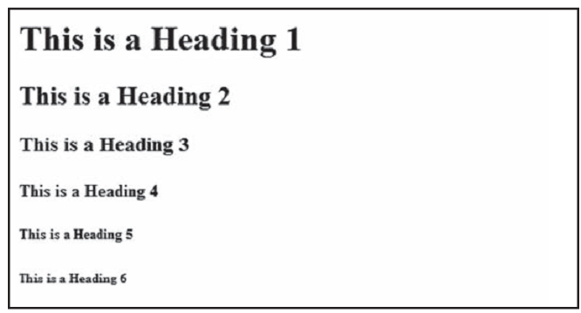

  - Horizontal Line
- A horizontal line across the browser page helps to visually separate the document
- Syntax: <hr/>
<p>The hr tag defines a horizontal rule:</p>  <hr/>  <p>This is a paragraph</p>  <hr/>  <p>This is a paragraph</p>  <hr/>  <p>This is a paragraph</p> | 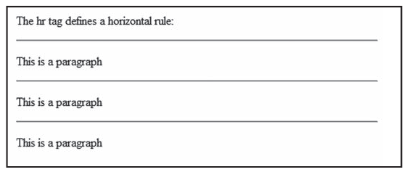

  - Comment – Other Special Characters
- Syntax: <!--conmment here-->
<!--This comment will not be displayed-->  <p>This is a regular paragraph</p> | 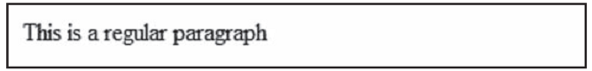

- HTML Paragraph
2.1 Paragraph
- HTML documents are divided into paragraph
- Note:
  - Browsers automatically add an empty line before and after paragraphs
  - Browsers automatically delete any extra spaces between words in paragraph
- Browsers automatically delete any lines in the paragraph
- Syntax: <p>…</p>
<p>This is a regular paragraph</p>
<p>  My Bonnie lies over the ocean.  My Bonnie lies over the sea.  My Bonnie lies over the ocean.  Oh, bring back my Bonnie to me.  </p>  <p>Note that your browser ignores your layout!</p> | 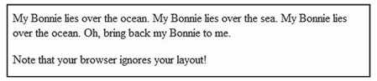

2.2 Line Breaks
- Break into the new line without starting a new paragraph
- Syntax: <br />
<p>This is<br />a para-<br />graph with line breaks</p> | 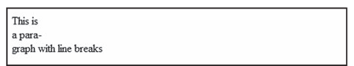

- HTML Formatting
Text Formatting tags  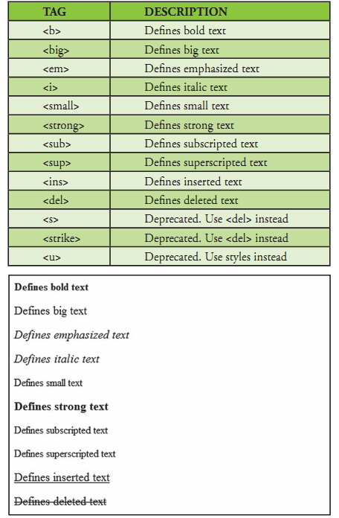 | Computer Output tags  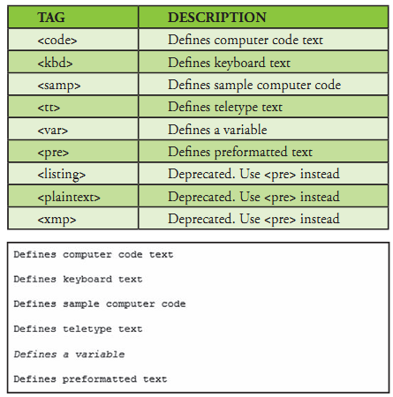
- Note: these tags are deprecated and should be replaced by CSS

  - Preformatted text
- Allow you to control the line breaks, spaces, and character widths
- Syntax: <pre>…</pre>
<pre>
This is
preformatted text.
It preserves both spaces
and line breaks and shows the text in a monospace font.
</pre>
<p>The pre tag is good for displaying computer code:</p>
<pre>
for i = 1 to 10
print i
next i
</pre>
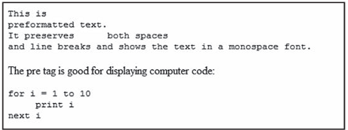

  - Address
- Allow you to write an address in an HTML document
- Syntax: <address>…</address>
<address>  Donald Duck<br>  BOX 555<br>  Disneyland<br>  USA  </address> | 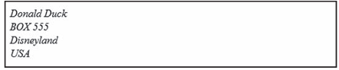

  - Abbreviations and acronyms (viết tắt)
- Syntax:
<abbr title="full name">abbreviations </abbr>
<acronym title="full name">acronyms</acronym>
<abbr title="United Nations">UN</abbr>
<br />
<acronym title="World Wide Web">WWW</acronym>
<p>
The title attribute is used to show the spelled-out
version when holding the mouse pointer over the acronym
or abbreviation.
</p>

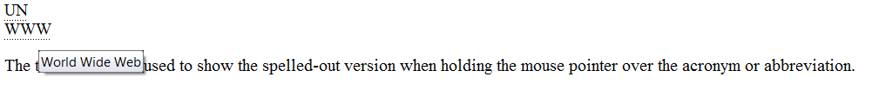

  - Quotation
- Syntax:
<blockquote>…</blockquote> (long quote)
<q>…</q> (short quote)
- Note: browsers automatically add an empty line before and after the <blockquote>
<p>A blockquote quotation:</p>
<blockquote>
This is a long quotation. This is a long quotation. This is
a long quotation. This is a long quotation. This is a long
quotation.
</blockquote>

<p>A short quotation:</p>
<q>This is a short quotation</q>
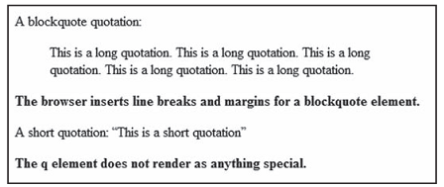

3.5 Deleted and Inserted
- Mark a text that is deleted(strikethrough) or inserted (underscore) to a document
- Syntax:
<del>...</del>
<ins>...</ins>
<p>
a dozen is
<del>twenty</del>
<ins>twelve</ins>
pieces
</p>
<p>
Most browsers will <del>overstrike</del> deleted text and
<ins>underscore</ins> inserted text.
</p>
<p>
Some older browsers will display deleted or inserted text as
plain text.
</p>
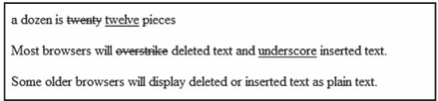

- HTML Link
  - Link/Hyperlink
- A link is the “address” to a document (or a resource)
- The term Hyperlink = any resource: image, document, music, movie,…
- Syntax: <a href="url">Link text</a>
- Note: a link will automatically be underlined
<a href="http://www.w3schools.com/">Visit w3schools!</a>

  - Anchor
- A hyperlink to a destination inside a document
- Syntax:
<a name="label">Any content</a> (label the destination)
<a href="#label">Any content</a> (the link to the destination in the same document)
<a href="abc.html#label">Any content</a> (link to the label in other document)
<p><a href="#C4">See also Chapter 4.</a></p>  <h2>Chapter 1</h2>  <p>This chapter explains ba bla bla</p>  <h2>Chapter 2</h2>  <p>This chapter explains ba bla bla</p>  <h2>Chapter 3</h2>  <p>This chapter explains ba bla bla</p>  <h2><a name="C4">Chapter 4</a></h2>  <p>This chapter explains ba bla bla</p> | 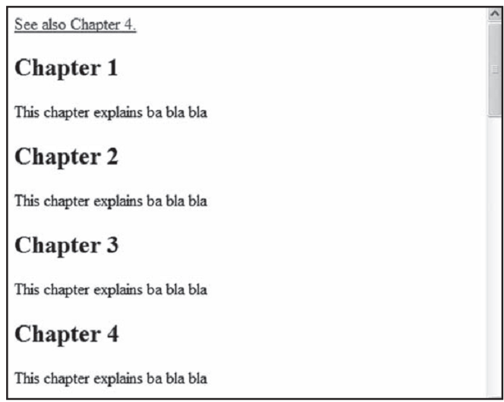

4.3 Mailto Link
- Link to an e-mail address and generate a new e-mail in your default e-mail application
<p> This is a mail link: </p>
<a href="mailto:someone@microsoft.com?subject=Hello%20again">Send Mail</a>
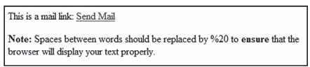

- This create an email with cc, bcc, subject and the message body
<p>This is another mailto link: </p>
<a href=”mailto:someone@microsoft.com?cc=someoneelse@microsoft.com&bcc=
andsomeoneelse2@microsoft.com&subject=Summer%20Party&body=You%20are%
20invited%20to%20a%20big%20summer%20party!”>Send mail!</a>
<p>
<b>Note:</b> Spaces between words should be replaced by %20 to <b>ensure</b> that the browser will display your text properly.
</p>
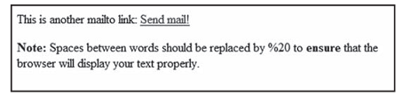

  - Image Link
- Syntax:<a href="url"> <img src=”photo” alt=”photo description” /></a>
<p>Create a link attached to an image:
<a href="default.htm"> <img src="smiley.gif" alt="HTML tutorial" width="32"
height="32" /></a></p>

<p>No border around the image, but still a link:
<a href="default.htm"> <img border="0" src="smiley.gif" alt="HTML tutorial"
width="32" height="32" /></a></p>
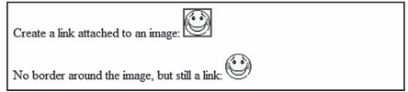

4.5 Attribute
Attribute | Value | Description
target |  | Specifies where to open all the links on a page
target | _blank | Open in a new window or tab
target | _self | Open in the same frame as it was clicked
target | _parent | Open in the parent frameset
target | _top | Open in the full body of the window
href | URL | Specifies the destination of a link
name |  | Specifies the name of an anchor

- HTML Image
5.1 <Image> Tag
- The url can be a link to an image
- Syntax: <img src="url" />
<p>An image: </p>
<img src="constr4.gif" width="144" height="50"/> //Image from the same folder
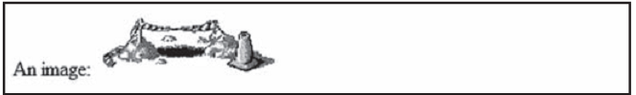

<p>An image from another folder:</p>
<img src="/images/chrome.gif" width="33" height="32"/> //Image from different folder

<p>An image from w3schools:</p>
<img src="http://www.w3schools.com/images/w3schools_green.jpg" width="104" height="142" /> //Image a website
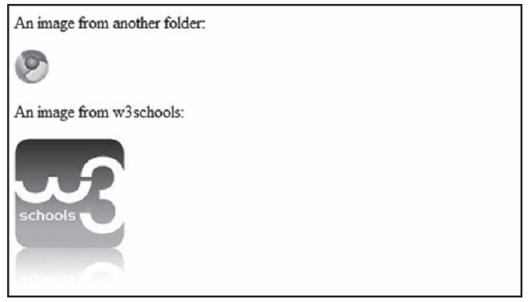

5.2 Background Image
- An image can be used as a HTML page background
- Syntax: <body background=”url”>
<html>
<body background="background.jpg">
<h3>Look: A background image!</h3>
<p>Both gif and jpg files can be used as HTML backgrounds.</p>
<p>If the image is smaller than the page, the image will re-peat itself.</p>
</body>
</html>
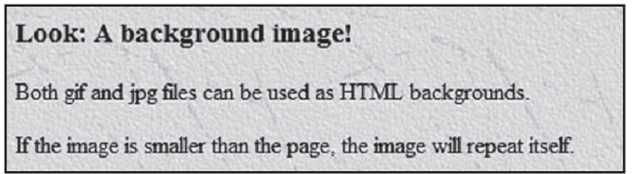

5.3 Align Attribute
- Syntax: <img src=”url” align=”value”/>
Value | Description
Bottom | The text is aligned at the bottom of image (default)
Middle | The text is aligned at the middle of image
Top | The text is aligned at the top of image
Left | The image is float to the left of the text
Right | The image is float to the right of the text

<p>This image appears  <img src="hackanm.gif" width="48" height="48"/>  exactly where it is placed in the code.  </p> | 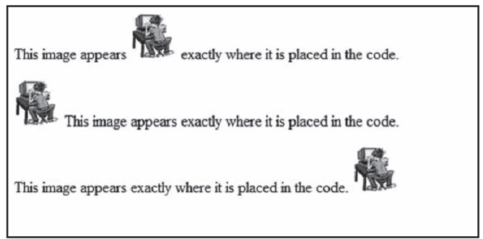
<p><img src="hackanm.gif" width="48" height="48"/> This image appears exactly where it is placed in the code.
</p>
<p>This image appears exactly where it is placed in the code.
<img src="hackanm.gif" width="48" height="48"/>
</p>
<p>The text is aligned with the image  <img src="hackanm.gif" align="bottom" width="48" height="48"/>  at the bottom.  </p> | 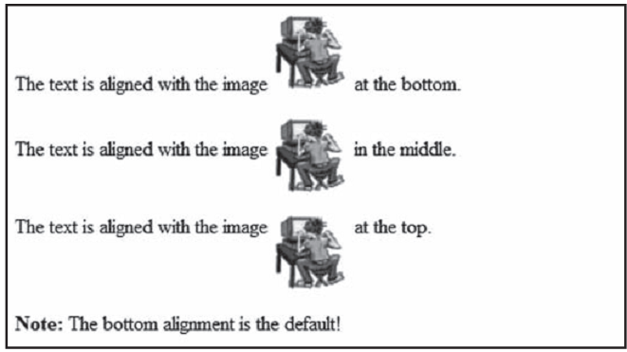
<p>The text is aligned with the image
<img src="hackanm.gif" align="middle" width="48" height="48"/>
in the middle.
</p>
<p>The text is aligned with the image
<img src="hackanm.gif" align="top" width="48" height="48"/>
at the top.
</p>
<p><img src="hackanm.gif" align="left" width="48" height="48"/>  A paragraph with an image. The align attribute of the image is set to "left". The image will float to the left of this text.</p> | 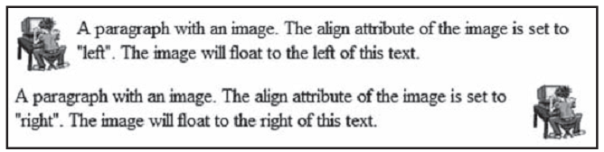
<p><img src="hackanm.gif" align="right" width="48" height="48"/>
A paragraph with an image. The align attribute of the image is set to "right". The image will float to the right of this text.</p>

  - Width and Height Attribute
- Syntax: <img src=”url” width=”value” height=”value”/>
- Value:
  - number/ number_px scale by pixel
  - %: scale by % of the original image
  - auto: auto scale
<p><img src="hackanm.gif" width="20" height="20" /></p>  <p><img src="hackanm.gif" width="45" height="45" /></p>  <p><img src="hackanm.gif" width="70" height="70" /></p> | 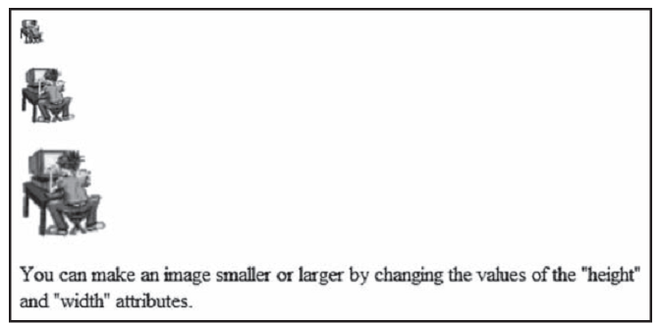

  - Alt Attribute
- Used to define an alternative text for image in case the webpage can’t load the image
- Syntax: <img src="url" alt="text"/>
<p>An image: <img src="../constr4.gif" alt=”Site_Under_Construction” width="200" height="50" /></p> | 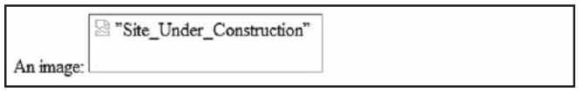

- HTML Table
6.1 Table
- A table cell can contain text, image, link, header, table,…
- Tags:
  - <table>…</table>: create a table
  - <tr>…</tr>: create a row
  - <td>…</td>: create a cell inside a row
  - <th>…</th>: heading in table
<table border="1">  <tr>  <td>100</td>  </tr>  </table>  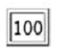 | <table border="1">  <tr>  <td>100</td>  <td>200</td>  <td>300</td>  </tr>  </table>  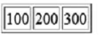
<table border="1">  <tr>  <td>100</td>  <td>200</td>  <td>300</td>  </tr>  <tr>  <td>400</td>  <td>500</td>  <td>600</td>  </tr>  </table>  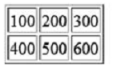 | <table border="1">  <tr>  <th>Heading</th>  <th>Another Heading</th>  </tr>  <tr>  <td>row 1, cell 1</td>  <td>row 1, cell 2</td>  </tr>  <tr>  <td>row 2, cell 1</td>  <td>row 2, cell 2</td>  </tr>  </table>  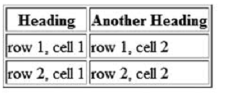

6.2 Empty Cell in a Table
- To prevent empty cell we should use the space character &nbsp;
<table border="1">  <tr>  <td>row 1, cell 1</td>  <td>row 1, cell 2</td>  </tr>  <tr>  <td>row 2, cell 1</td>  <td></td>  </tr>  </table>  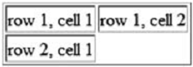 | <table border="1">  <tr>  <td>row 1, cell 1</td>  <td>row 1, cell 2</td>  </tr>  <tr>  <td>row 2, cell 1</td>  <td>&nbsp;</td>  </tr>  </table>  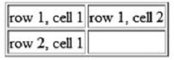

6.3 Cell Spanning
- Column spanning: <th/td/tr colspan=”...”>
- Row spanning: <th/td/tr rowspan=”...”>
<table border="1">  <tr>  <th>Name</th>  <th colspan="2">Telephone</th>  </tr>  <tr>  <td>Bill Gates</td>  <td>555 77 854</td>  <td>555 77 855</td>  </tr>  </table>  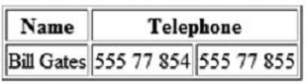 | <table border="1">  <tr>  <th>First Name:</th>  <td>Bill Gates</td>  </tr>  <tr>  <th rowspan="2">Telephone:</th>  <td>555 77 854</td>  </tr>  <tr>  <td>555 77 855</td>  </tr>  </table>  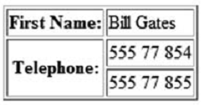

6.3 Table Caption
- Syntax: <caption>My Caption</caption>
<table border="6">  <caption>My Caption</caption>  <tr>  <td>100</td>  <td>200</td>  <td>300</td>  </tr>  <tr>  <td>400</td>  <td>500</td>  <td>600</td>  </tr>  </table> | 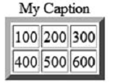

  - Attribute
- Border attribute syntax: <table border=”…”>…</table>
<table border="1">  <tr>  <td>First</td>  <td>Row</td>  </tr>  <tr>  <td>Second</td>  <td>Row</td>  </tr>  </table>  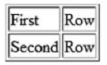 | <table border="8">  <tr>  <td>First</td>  <td>Row</td>  </tr>  <tr>  <td>Second</td>  <td>Row</td>  </tr>  </table>  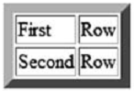 | <table border="15">  <tr>  <td>First</td>  <td>Row</td>  </tr>  <tr>  <td>Second</td>  <td>Row</td>  </tr>  </table>  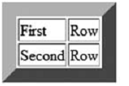

- cellpadding attribute syntax: <table border="1" cellpadding="…">
- Create more white space between the cell content and its borders
<table border="1" cellpadding="10">  <tr>  <td>First</td>  <td>Row</td>  </tr>  <tr>  <td>Second</td>  <td>Row</td>  </tr>  </table> | 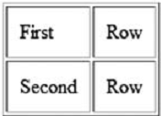

- cellspacing attribute syntax: <table border="1" cellspacing="…">
- Increase the distance between the cell
<table border="1" cellspacing="10">  <tr>  <td>First</td>  <td>Row</td>  </tr>  <tr>  <td>Second</td>  <td>Row</td>  </tr>  </table> | 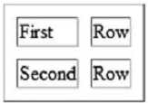

- align attribute syntax:
<th align="value">
<td align="value">
Value | Description
Left | All contents in the cell are on the left
Right | All contents in the cell are on the right
Center | All contents in the cell are in the center

<table width="400" border="1">  <tr>  <th align="left">Money spent on</th>  <th align="right">January</th>  <th align="right">February</th>  </tr>  <tr>  <td align="left">Clothes</td>  <td align="right">$241.10</td>  <td align="right">$50.20</td>  </tr>  <tr>  <td align="left">Make-Up</td>  <td align="right">$30.00</td>  <td align="right">$44.45</td>  </tr>  <tr>  <td align="left">Food</td>  <td align="right">$730.40</td>  <td align="right">$650.00</td>  </tr>  <tr>  <th align="left">Sum</th>  <th align="right">$1001.50</th>  <th align="right">$744.65</th>  </tr>  </table> | 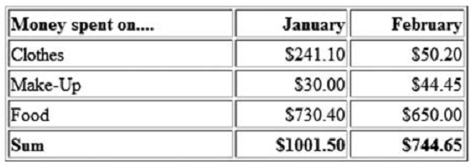

- Frame attribute syntax: <table frame=”value”>
- Control the borders around the table
<table frame="border">  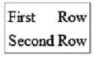 | <table frame="box">  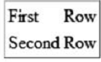 | <table frame="void">  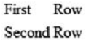
<table frame="above">  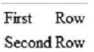 | <table frame="below">  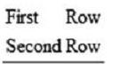 | <table frame="hsides">  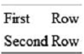
<table frame="vsides">  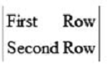 | <table frame="lhs">  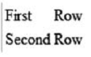 | <table frame="rhs">  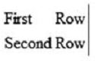

- HTML List
7.1 Unordered Lists
- Syntax: <ul>…</ul>
- Display the list using bullet, square, circle,…
<ul type="disc">  <li>Apples</li>  <li>Bananas</li>  <li>Lemons</li>  </ul>  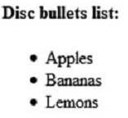 | <ul type="circle">  <li>Apples</li>  <li>Bananas</li>  <li>Lemons</li>  </ul>  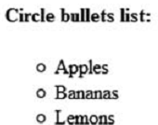 | <ul type="square">  <li>Apples</li>  <li>Bananas</li>  <li>Lemons</li>  </ul>  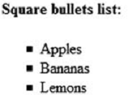

7.2 Ordered Lists
- Syntax: <ol>…</ol>
- Display the list using number, Roman number,…
<ol>  <li>Coffee</li>  <li>Tea</li>  <li>Milk</li>  </ol>  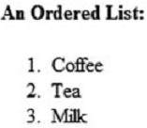 | <ol type="A">  <li>Apples</li>  <li>Bananas</li>  <li>Lemons</li>  </ol>  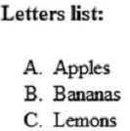 | <ol type="a">  <li>Apples</li>  <li>Bananas</li>  <li>Lemons</li>  </ol>  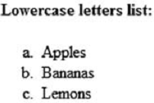
<ol type="I">  <li>Apples</li>  <li>Bananas</li>  <li>Lemons</li>  </ol>  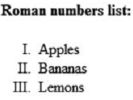 | <ol type="i">  <li>Apples</li>  <li>Bananas</li>  <li>Lemons</li>  </ol>  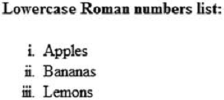

7.3 Definition List
- Tags:
<dl>…</dl>: definition list
<dt>…</dt>: definition term
<dd>…</dd>: definition description
<dl>  <dt>Coffee</dt>  <dd>Black hot drink</dd>  <dt>Milk</dt>  <dd>White cold drink</dd>  </dl> | 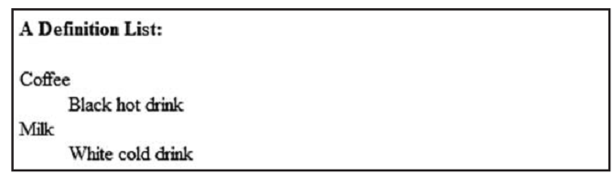
B. HTML Advanced
- HTML Frames
- Definition and Advantages:
  - With frames, more HTML documents can be displayed on the same browser window
  - Each HTML document is called a frame
  - Each frame is independent with each other
- Disadvantage of Frames:
  - Must keep track of more HTML documents
  - User always hate them
  - Difficult to print the entire page
  - Linking challenge
  - A HTML document that contains frames means it can’t content text, picture,…

  - Frame Tag
- Frameset: <frameset>...</frameset>
- Vertical frameset: <frameset cols=”size”>...</frameset>
- Horizontal frameset: <frameset rows=”size”>...</frameset>
- Frame: <frame src=”url”>
- The value of attribute “cols” and “rows”:
  - Pixel (Ex: 50 or 50px)
  - Percentage (Ex: 50%)
  - * - which can be used in many ways:
    - “40,*” - the 1st frame is 40pixel, the 2nd frame is the rest of the browser window
    - “*,*” the 1st frame = the 2nd frame
    - “*,2*” the 2nd frame = 2 time the 1st frame

<frameset cols="25%,50%,25%">  <frame src="frame_a.htm">  <frame src="frame_b.htm">  <frame src="frame_c.htm">  </frameset> | 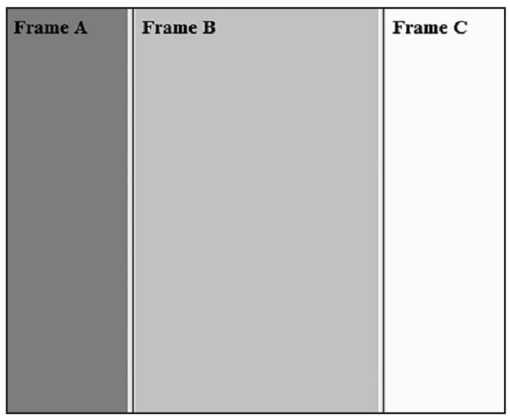
<frameset rows="25%,50%,25%">  <frame src="frame_a.htm">  <frame src="frame_b.htm">  <frame src="frame_c.htm">  </frameset> | 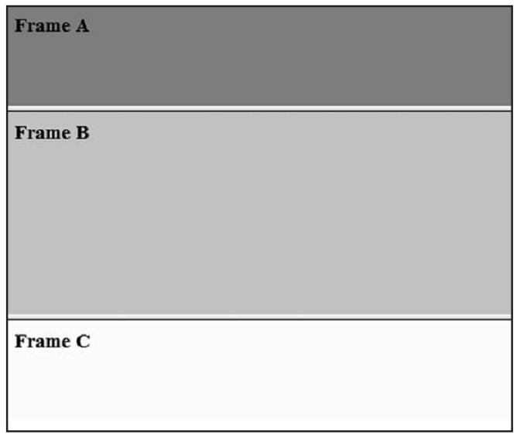
<frameset rows="50%,50%">  <frame src="frame_a.htm">  <frameset cols="25%,75%">  <frame src="frame_b.htm">  <frame src="frame_c.htm">  </frameset>  </frameset> | 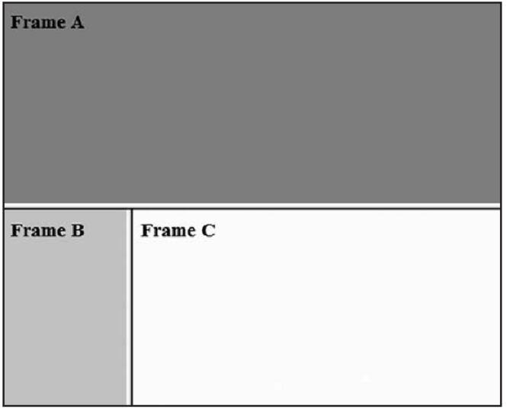
  - NoFrames Tag
- Some old browsers don’t support frame. We use noframes tag to show the body in case the frame fail
- Syntax:
<frameset ...>
...
<noframes>
<body>
...
</body>
</noframes>
</frameset>
<frameset cols="25%,50%,25%">
<frame src="frame_a.htm">
<frame src="frame_b.htm">
<frame src="frame_c.htm">
<noframes>
<body>Your browser does not handle frames!</body>
</noframes>
</frameset>

  - Navigation Frame
- In the browser window we have 2 frames
  - The navigation frame (1st frame): contains the link to the HTML documents. When we click these links the documents will be displayed to the 2nd frame
  - The content frame (2nd frame): display the HTML documents
- Syntax:
  - Identify the name for the 2nd frame:
<frame src=”url” name=”frame2”>
  - Link the 1st frame to the HTML document which contain the links
  - In the document which contain the links, the links must target to the 2nd frame:
<a href=”url” target=”frame2”>

In the main HTML document:  <frameset cols="120,*">  <frame src="tryhtml_contents.htm">  <frame src="frame_a.htm" name="showframe">  </frameset>  In the links HTML document:  <a href ="frame_a.htm" target ="showframe">Frame a</a><br>  <a href ="frame_b.htm" target ="showframe">Frame b</a><br>  <a href ="frame_c.htm" target ="showframe">Frame c</a> | 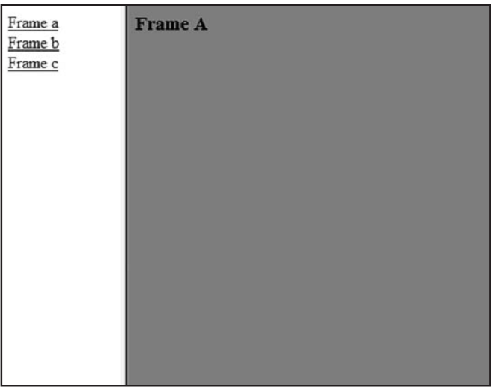

  - Jump to
- Jump to an anchor inside an HTML document using the frame
- Syntax: <frame src=”url#name”>
In the HTML document:  <a name=”C10”>Chapter 10</a>  In the frame HTML document:  <frameset cols="20%,80%">  <frame src="frame_a.htm">  <frame src="link.htm#C10">  </frameset> | 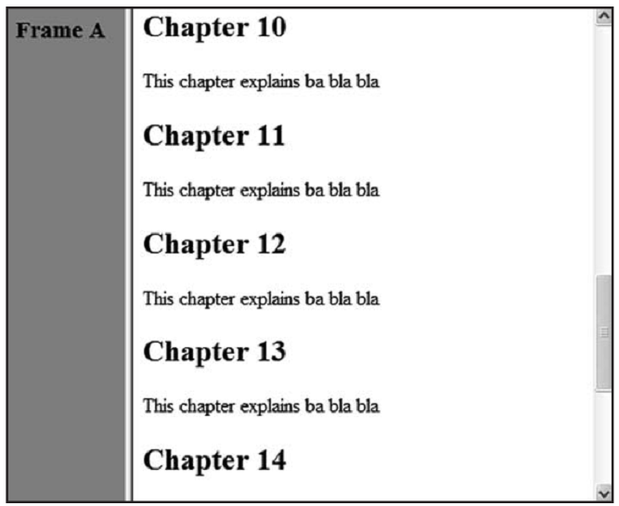
We can also use the navigation frame to link to the anchor  In the HTML document:  <a name=”C10”>Chapter 10</a>  In the frame HTML document:  <frameset cols="180,*">  <frame src="content.htm">  <frame src="link.htm" name="showframe">  </frameset>  In the navigation HTML document:  <a href="link.htm" target ="showframe">Link without Anchor</a><br>  <a href="link.htm#C10" target="showframe">Link with Anchor</a>. | 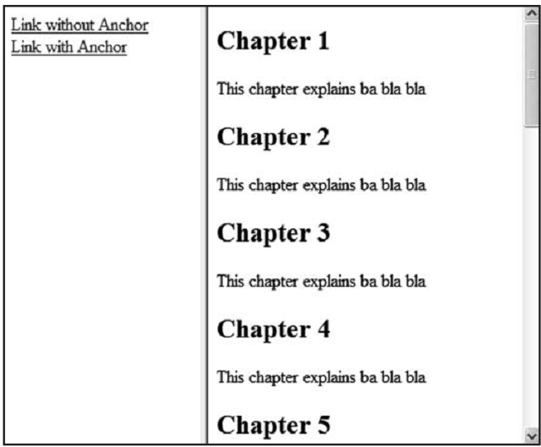

  - Inline Frame (Floating Frame) & Div
- If we want a HTML document that has text, photo,… along with a frame, we can use inline frame
- Syntax: <iframe src=”url”>...</iframe>
- If we want a position-able block of content, we can use div (must use with CSS)
- Syntax: <div>...</div>

<body>  <iframe src="default.asp"></iframe>  <p>Some older browsers don't support iframes.</p>  <p>If they don't, the iframe will not be visible.</p>  </body> | 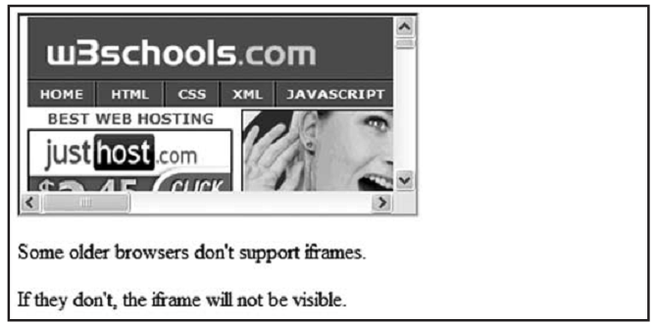

- References
